

DLD Lab-07

Magnitude Compactor



NATIONAL UNIVERSTIY OF COMPUTER AND EMERGING SCIENCES, FAST- Peshawar Campus

Department Of Computer Science

Instructor: Engr. Waseem Ullah

EL 1005– Digital Logic Design-Lab

SEMESTER SPRING 2022

Contents

1. Objectives: 2

2. Digital Comparator 2

3. Magnitude Comparator 3

4. 1-Bit Magnitude Comparator 3

5. 2-Bit Magnitude Comparator 6

6. How to design a 4–bit comparator? 9

7. Applications of Comparators 11

8. Code converters 12

9. BCD, Excess-3 code 12

10. Binary, BCD, Excess-3 code 13

11. Students Task 15

# Objectives:

**Magnitude Comparator**

1. Design and implement the circuitry for 1-bit magnitude comparator.
2. Design and implement the circuitry for 2-bit magnitude comparator.
3. Design and implement the circuitry for 4-bit magnitude comparator

* Truth Table
* K-Map
* Equation
* Circuit Diagram
* Implementation

**Code Converters**

Design and implement the circuitry for a BCD-to-Excess 3 Code Converter.

# Digital Comparator

* It is a combinational (circuit without memory) logic circuit.
* Digital Comparator is used to compare the value of two binary digits.
* There are two types of digital comparator

**(i) Identity Comparator**

**(ii) Magnitude Comparator.**

* **IDENTITY COMPARATOR:** 
  + This comparator has only one output terminal for when A=B, either A=B=1 (High) or A=B=0 (Low)
* **MAGNITUDE COMPARATOR:**
  + This Comparator has three output terminals namely **A>B, A=B, A<B**. Depending on the result of comparison, one of these output will be high (1)
* Block Diagram of Magnitude Comparator is shown below in Fig. 1

# Magnitude Comparator

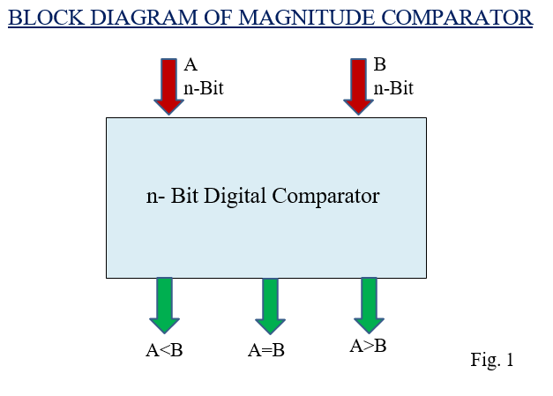

# 1-Bit Magnitude Comparator

1. This magnitude comparator has two inputs A and B and three outputs:
2. **A<B, A=B and A>B.**
3. This magnitude comparator compares the two numbers of single bits.
4. Truth Table of 1-Bit Comparator

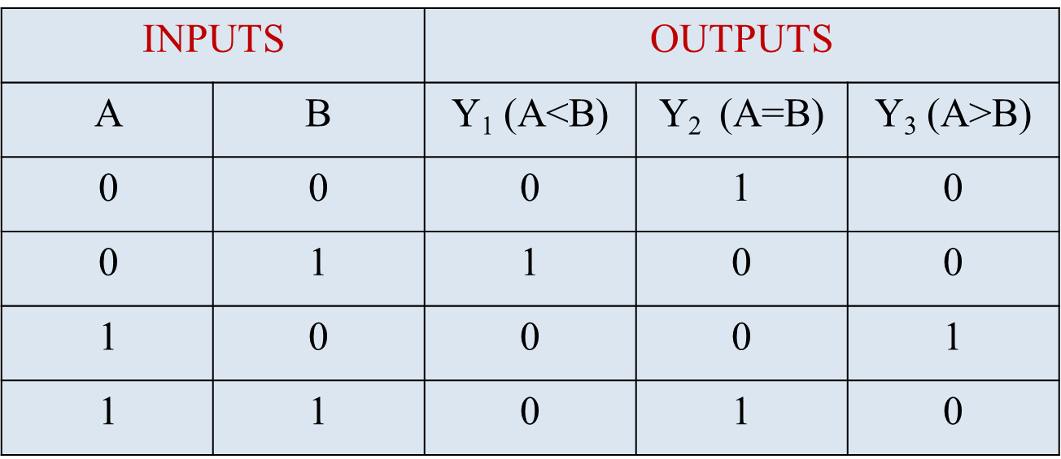

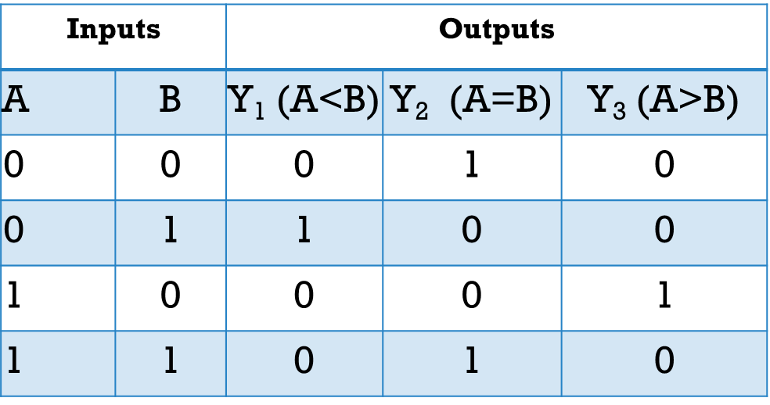

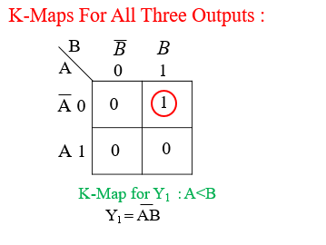 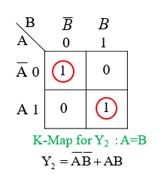

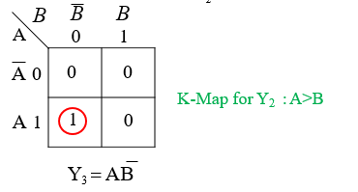

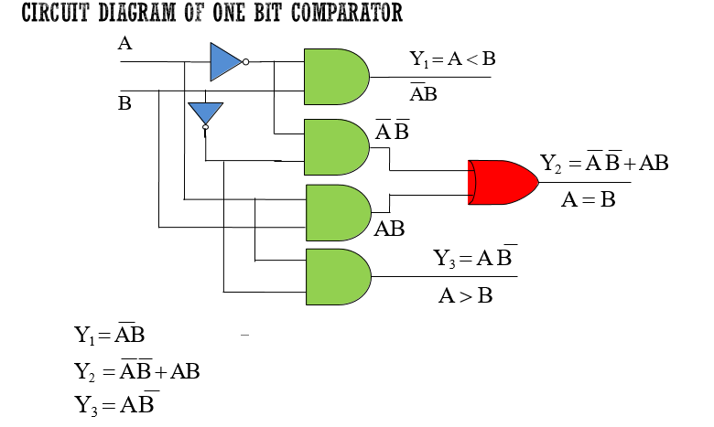

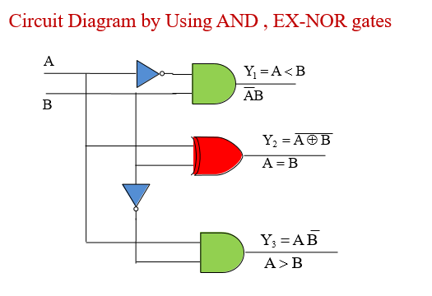

# 2-Bit Magnitude Comparator

* A comparator which is used to compare two binary numbers each of two
* bits is called a 2-bit magnitude comparator.
* Fig. 2 shows the block diagram of 2-Bit magnitude comparator.
* It has four inputs and three outputs.
* Inputs are A0 ,A1,B0 and B1 and Outputs are Y1, Y2 and Y3

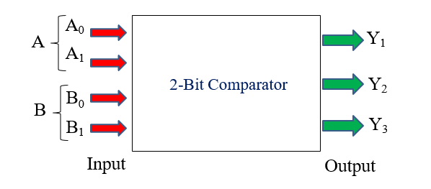

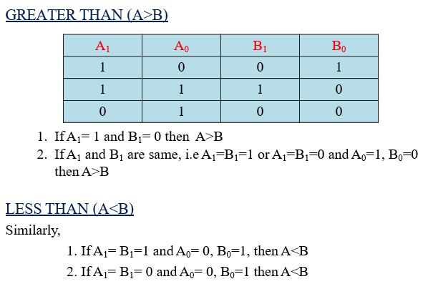

TRUTH TABLE

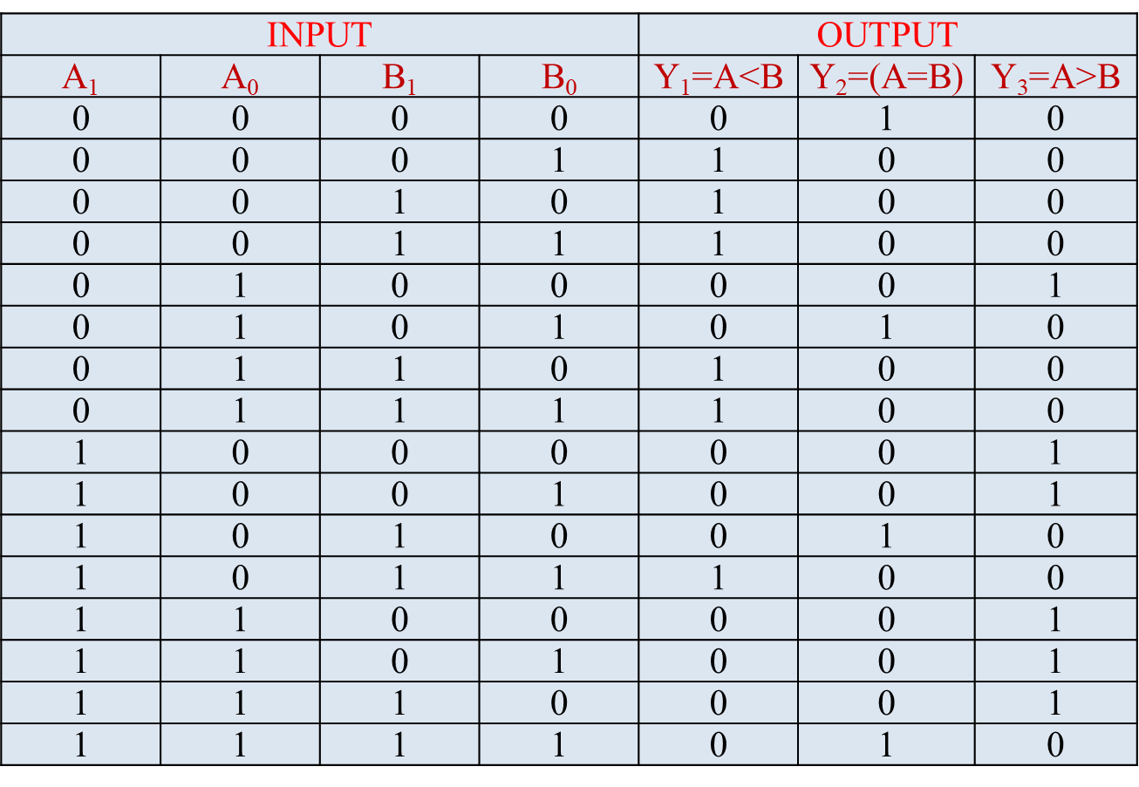

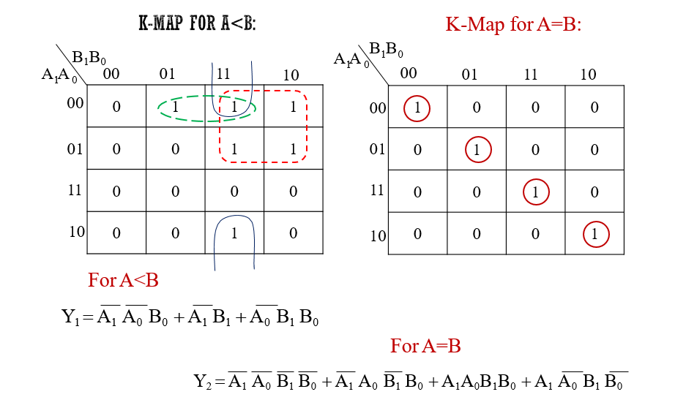

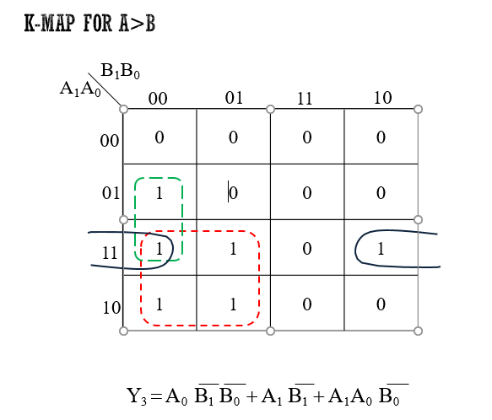

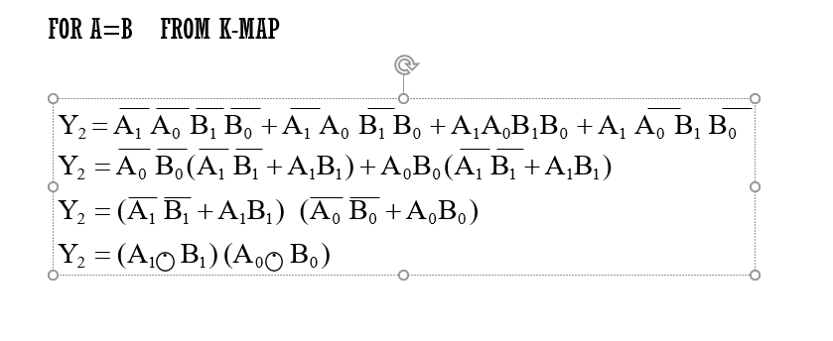

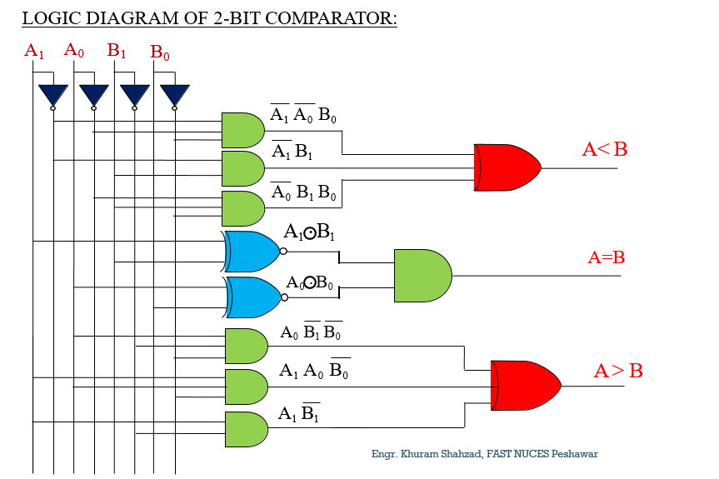

# How to design a 4–bit comparator?

The truth table for a 4-bit comparator would have 4^4 = 256 rows. So we will do things a bit differently here. We will compare each bit of the two 4-bit numbers, and based on that comparison and the weight of their positions, we will draft a truth table.

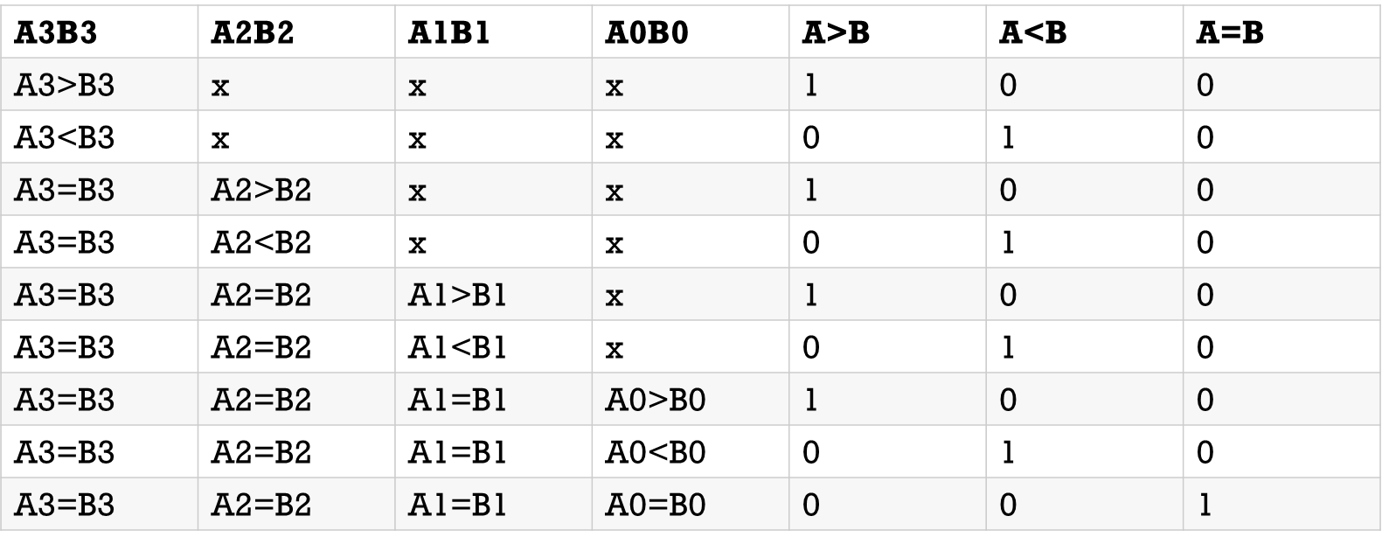

* **In a 4-bit comparator the condition of A>B can be possible in the following four cases:**

If A3 = 1 and B3 = 0

If A3 = B3 and A2 = 1 and B2 = 0

If A3 = B3, A2 = B2 and A1 = 1 and B1 = 0

If A3 = B3, A2 = B2, A1 = B1 and A0 = 1 and B0 = 0

* **Similarly the condition for A<B can be possible in the following four cases:**

If A3 = 0 and B3 = 1

If A3 = B3 and A2 = 0 and B2 = 1

If A3 = B3, A2 = B2 and A1 = 0 and B1 = 1

If A3 = B3, A2 = B2, A1 = B1 and A0 = 0 and B0 = 1

* **The condition of A=B is possible only when all the individual bits of one number exactly coincide with corresponding bits of another number.**
* **A=B: (A3 Ex-Nor B3) (A2 Ex-Nor 82) (Al Ex-Nor BI) (AO Ex-Nor BO)**

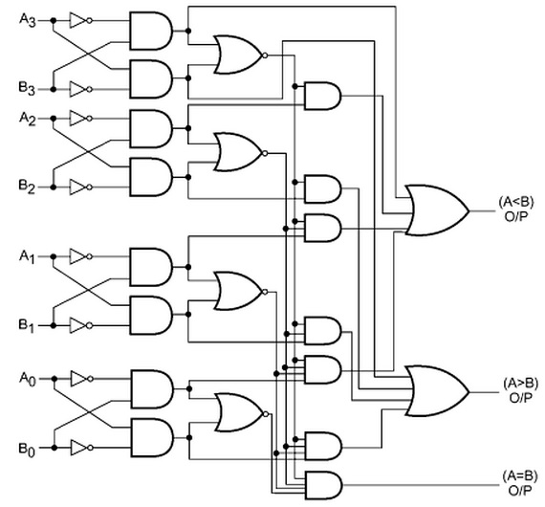

# Applications of Comparators

* *These are used in the address decoding circuitry in computers and microprocessor based devices to select a specific input/output device for the storage of data.*
* *These are used in control applications in which the binary numbers representing physical variables such as temperature, position, etc. are compared with a reference value. Then the outputs from the comparator are used to drive the actuators so as to make the physical variables closest to the set or reference value.*
* *Process controllers*
* *Servo-motor control*
* *Used in password verification and biometric applications.*

# Code converters

* The Code converter is used to convert one type of binary code to another.
* There are different types of binary codes like BCD code, gray code, excess-3 code, etc. Different codes are used for different types of digital applications.
* To get the required code from any one type of code, the simple code conversion process is done with the help of combinational circuits.
* A code converter circuit will convert coded information in one form to a different coding form.

# BCD, Excess-3 code

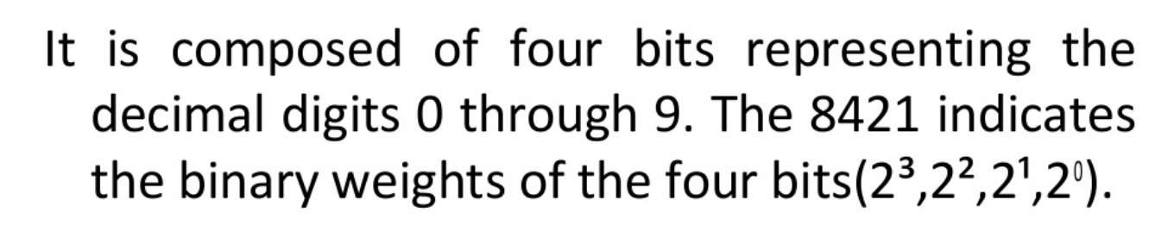

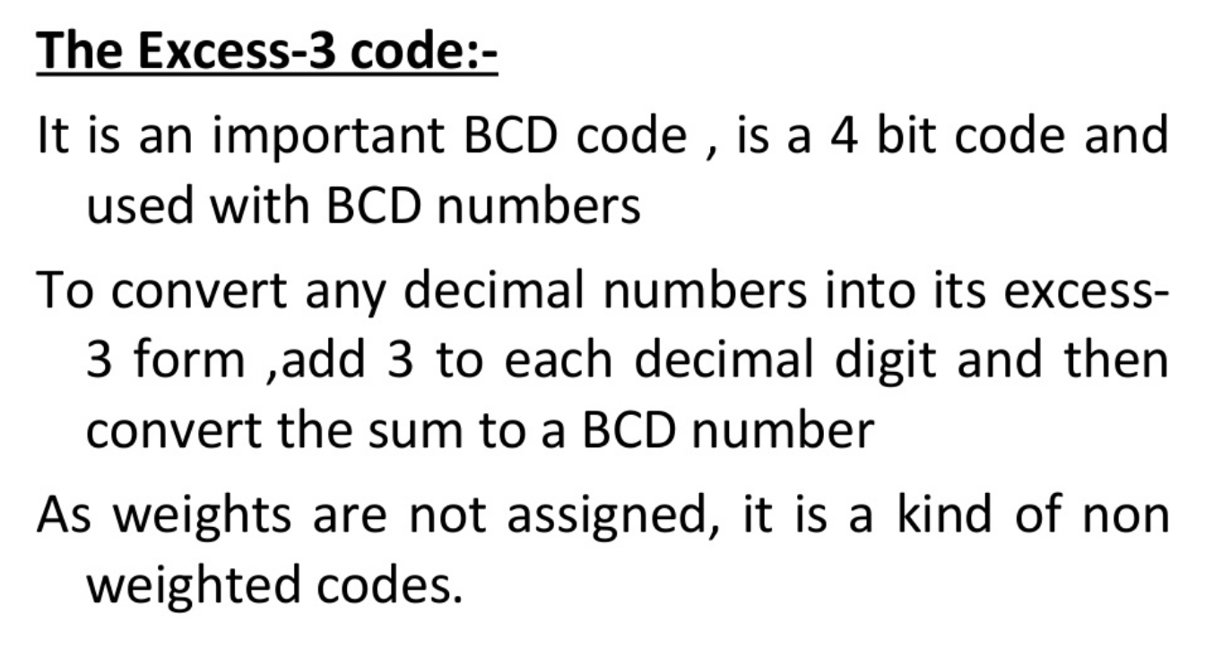

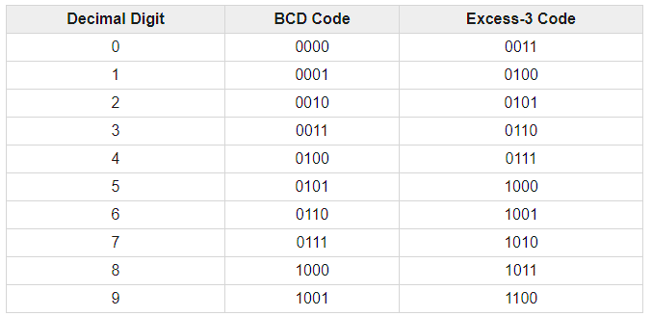

# Binary, BCD, Excess-3 code

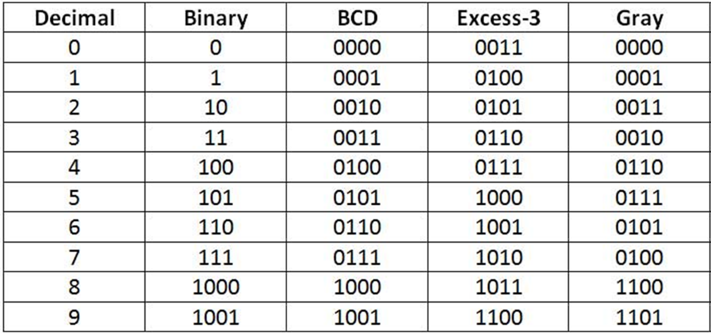

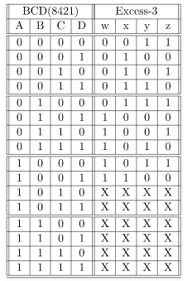

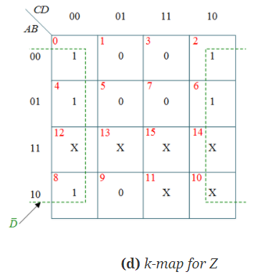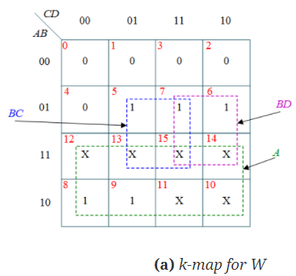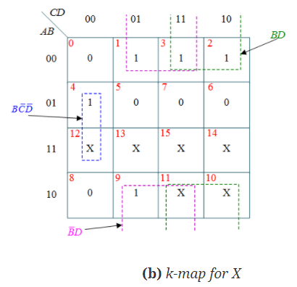

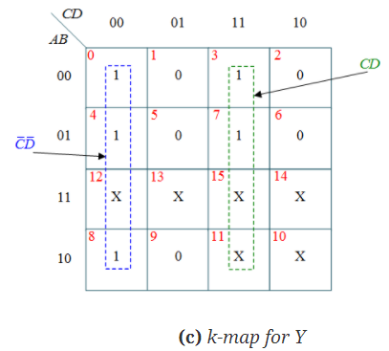

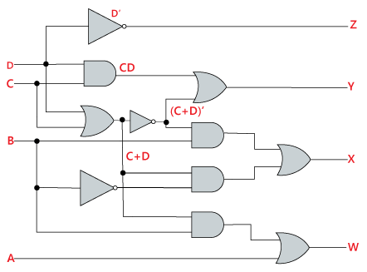

# Students Task

* Implement 1 bit, 2 bit and 4 bit comparator on logic lay
* Implement Excess 3 Converter circuit on on logic ly
* Design K-map and circuit diagram for Gray Code like Excess 3